Evan Jones
U.S. Olympic & Paralympic Committee Practicum
Bi-weekly progress report
Week ending March 23rd

Mr. Schwartz,
In the past two weeks I’ve made some solid progress on the final deliverables of the project. Firstly, I completed the central dashboard for the web application which focuses on the individual view of age analysis in alpine skiing. The dashboard itself allows the user to select an alpine skier, and the dashboard automatically populates several graphs and figures that demonstrate their career and past performance. Among these charts & figures include an athlete bio/information section, pie chart of past season alpine event participation, scatterplot of normalized career competition rank vs. normalized difficulty, bar chart of podiums by event and season, world ranking by event line chart, peak event world ranking kde plot (with bandwidth and kernel selection options), peak individual event rank kde plot (with bandwidth and kernel selection options), and career history plot with various spline, bspline, & polynomial regression fit options. See the screenshots provided below for a sneak peek of the dashboard. As a mentioned in my previous weekly update, I spent some time looking into your suggestion of a view of age through the individual athlete lens rather than just the aggregate event level view. With this approach in mind, I constructed two new kde models one focusing on peak world ranking and overall best individual rank. For both approaches, I collected all world record and timed event data for a given event gender pair. I then grouped these events by individual competitor and found each competitors peak world ranking/smoothed career ranking respectively. Each of these peak individual performances were then aggregated and kernel density estimation was applied. These resulting kde curve thus represent the estimated density of peak performance levels by age. They both provide more evidence to drawing conclusions about the impact of athlete age on various alpine event and gender pairs. In addition to this, I added an uploads page to the web application which will allow users of the dashboard to upload new event data directly within the application. After receiving the upload, the dash will clean and reconcile the new data to conform with the existing data and append the new rows. Work has begun on the events level dashboard and is coming along nicely as is the country level analysis. In the coming weeks I plan to continue finishing up the event and country level dashboards and combining my analysis into a page in the web app titled “Methodology” which will provide a complete walkthrough of the entire project, process, and conclusions. Let me know if you have any questions and I will be happy to clarify. Thanks.

Best regards,

Evan Jones
evanjones@gatech.edu
678-588-8666

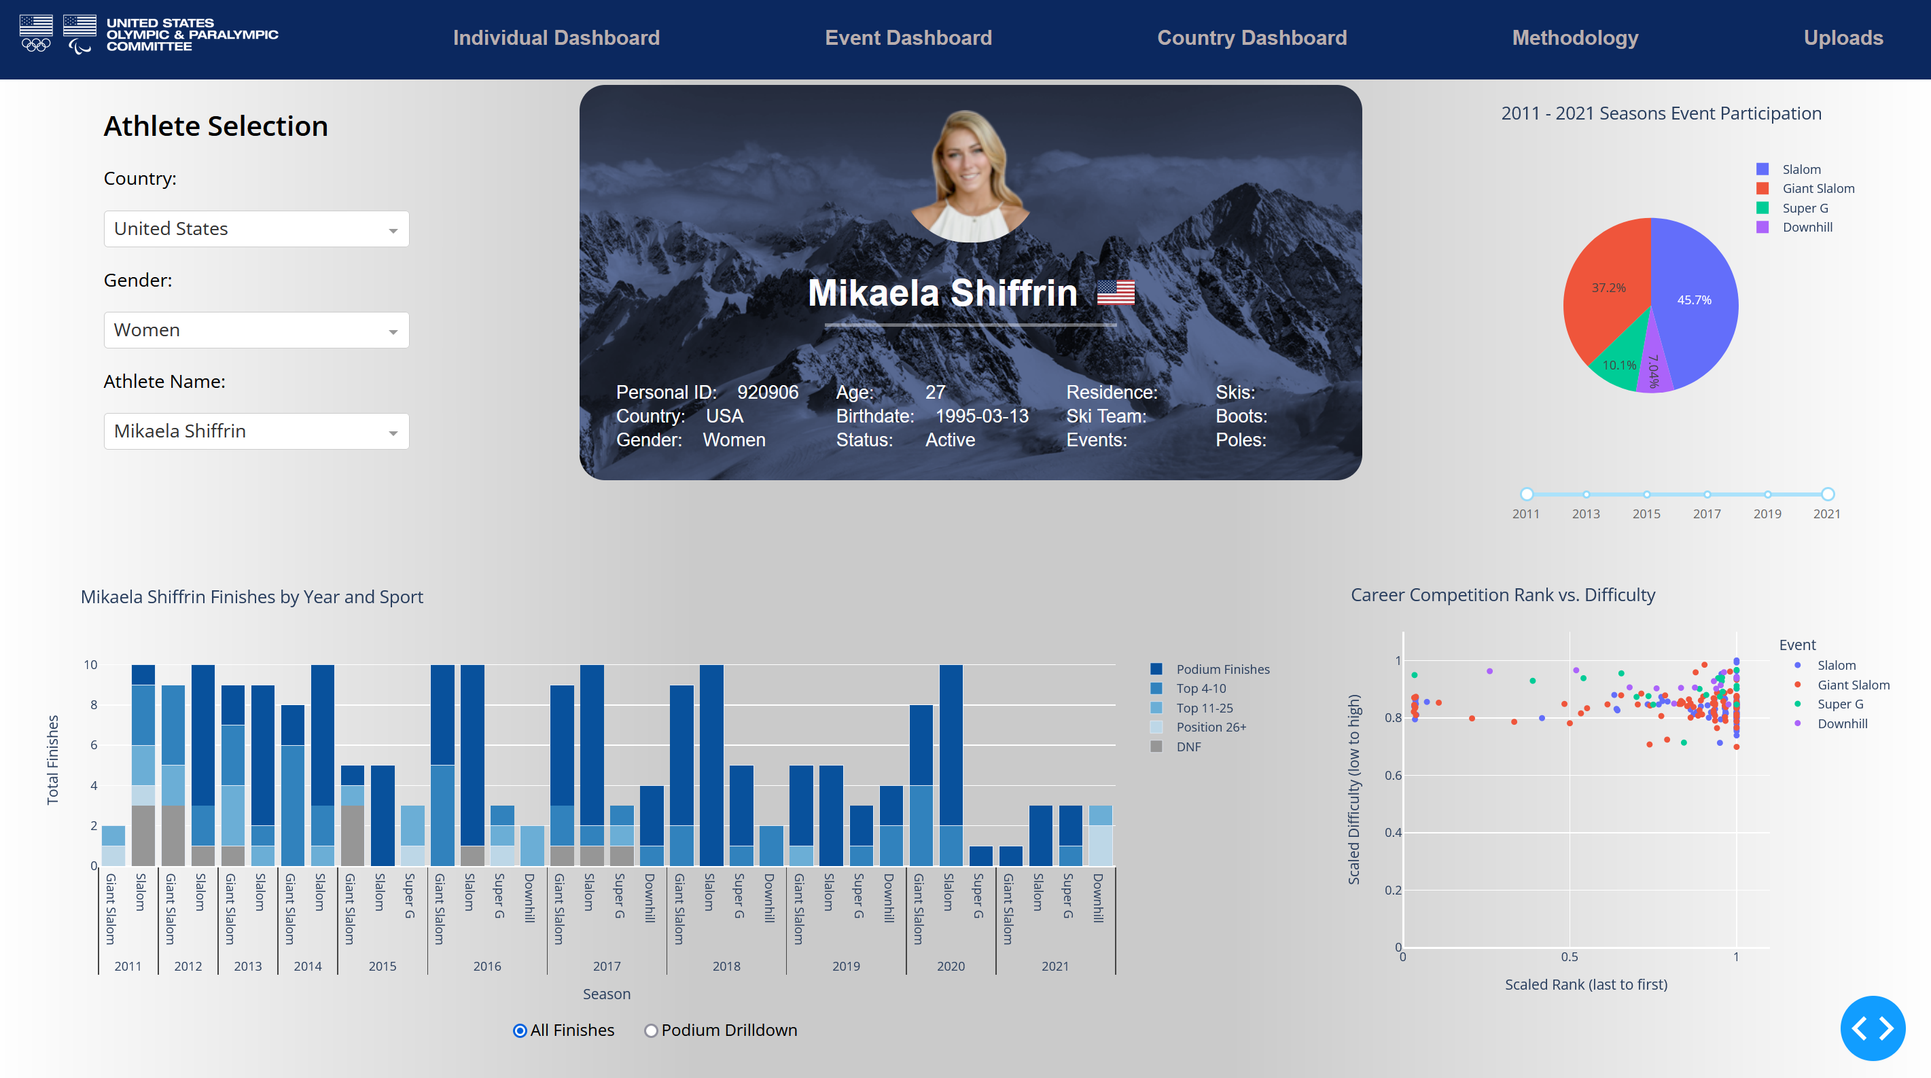

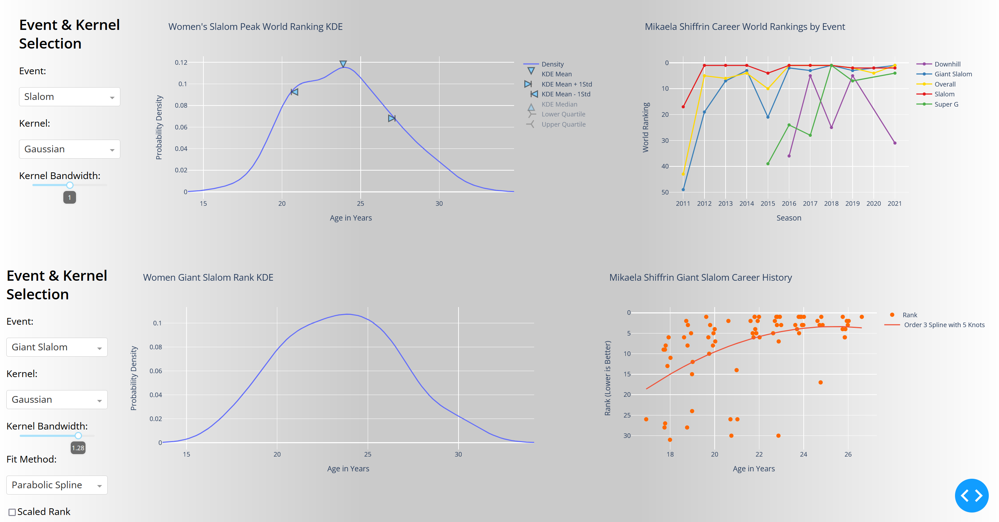

Evan Jones: United States Olympic & Paralympic Committee Revised Practicum Plan
Week | Week Ending | Planned | Completed | Other Notes
1 | January 19th | - Narrow sport scope to single discipline  - Get familiarized with data structure and project goals  - Exploratory data analysis with an eye towards data cleaning and formatting | - Alpine Skiing selected  - Organized and learned about data structure  - Identified droppable columns; Noticed fair amount of missing entries
2 | January 26th | - Construct some histograms to test basic age to medaling frequency and relationship  - Research Alpine 12 unique events; sport governing bodies; scoring and ranking mechanics  - Apply some cursory data cleaning and formatting  - Identify and correct datatypes for database import | - Created histogram with clear relationship  - Extensive notes and annotations taken on specific sport and event details  - Dropped columns which were mostly null or near duplicates  - Fixed pandas typing issues  - Create coding system for missing, blank, nan, and other edge case field entries  - Researched methods for filling missing data
3 | February 2nd | - Create local MySQL database and load in data  - Create python Selenium script for datamining International Ski Federation website for athletes  - Separate and split team events from solo events  - Compare histograms for different gender/event pairs to check similarities (see if sports should be combined or not) | - Local database created and working  - Selenium script created and working; filled most missing values for age; scraped profile photos for visualization purposes later.  - Data separated by team and gender groupings  - Utility of combining event data still unclear further analysis needed
4 | February 9th | - Organize data into format ready for KDE  - Apply KDE to Men’s Super G as a test run; Tune bandwidth; Test target variable approach medaling in general vs. specific medal.  - Compile list of regulation changes for events  - Add documentation to Selenium script/notebook | - Data formatted for KDE; initial results look promising.  - Created bandwidth tuning interactive sliders for ad-hoc experimentation and visualization  - Compiled list of impactful regulation changes and possible data adjustment remedies  - Selenium documentation added
5 | February 16th | - Research masking methods for train/test given problem setup  - Apply remedies for regulations and necessary data adjustments  - Fit KDE models on all solo events  - Begin work on midterm slide deck | - Train & Testing years/masked determined  - Decided to utilize only post reg data, but to include a dashboard view for better understanding of the impact of regulation changes  - Fit KDE models on solo events  - Developed diagrams for Midterm slide deck
6 | February 23rd | - Create country historic and forward-looking pipeline profiles which at each Olympic date contain competitors used; unused; and medal outcomes  - Create selenium script for updating country pipelines as new athletes are entered in the FIS database.  - Finish midterm slide deck | - Pipeline creation in progress, but not complete as of weekend  - Finished midterm report presentation slides  - Created flexible support for new athlete entries | Midterm slide deck/report due
7 | March 2nd | - Start layout and design work on Dash dashboard structure  - Setup multi-page web app layout  - Create landing page  - Convert KDE models into dash friendly representation | - Multi-page dash app created  - Finalized file structure for the application  - Added global scss components and style sheets  - Finalized application landing page  - KDE models converted to dash interactive plot for customized hyperparameter selection. | Revised Project plan to utilize Dash instead of Tableau causes some changes in overall plan
8 | March 9th | - Create FIS image scraper for athlete profile images  - Create all dash components and callbacks for the individual athlete view dashboard page  - Create repo for country flags  - Finish work on KDE descriptive stats and chi squared test | - Created image scraper used as design elements in dash  - Created svg repository for displaying specific country and Olympic flags used as design elements in dash  - Finished all callbacks and components on the individual athlete view dashboard  - Began work on Event level dashboard  - Took Elliot’s advice about viewing age from the individual achievement perspective did some cursory modeling here  - Finished KDE analysis
9 | March 16th | - Finalize individual athlete peak achievement view of age analysis  - Add visualization that contrasts the two different age modeling approaches.  - Start work on the event view dashboard | - Finished the individual view dashboard  - Started work on the new event dashboard  - Finished 3 peak age modeling approaches focusing on peak world ranking achieved by event; peak event rank achieved; and peak scaled / smoothed rank achieved.  - Visualizations created for both approaches
10 | March 23rd | - Finish work on the event view dashboard  - Begin country pipeline level analysis and prediction  - Begin work on the last country view dashboard | - Significant work accomplished on the event view dashboard, but not complete just yet  - Pipeline analysis started and developing well  - Created upload page to allow users of the web application the ability to upload new event data via csv which automatically cleans and reconciles the new dataset with the existing dataset.  - Methodology page created to layout analysis  - Country view dashboard created and work is continuing in development.
11 | March 30th | - Aggregate all production quality models and predictions  - Detailed hyperparameter tuning  - Pickle models for reuse  - Finish country pipeline analysis  - Finish country pipeline dash page
12 | April 6th | - Cushion week for anything that went longer than expected
13 | April 13th | - Organize and add documentation to repository  - Cushion week for anything that went longer than expected
14 | April 20th | - Prepare final report and touch up |  | Final report due

